A
Synopsis Report
On
“UrbanFlow
A Traffic Simulation Engine”
Submitted in Partial Fulfillment of the Requirements for the
Award of the Degree of
Bachelor of Technology
in
Computer Science and Engineering

Submitted by
Raghvendra Pratap Singh (202310101110329)
Anurag Verma (202310101110324) | Awnish Yadav (202310101110334)

Under the Guidance of
Mrs. Neha Anand
Assistant Professor
Department of Computer Science & Engineering
Institute Of Technology



Shri Ramswaroop Memorial University
Lucknow – Deva Road, Barabanki (UP)
Index

S.No. Contents Page No.

1 | Introduction | 3
2 | Project Mission | 4
3 | Methodology | 5-6
4 | Tools/Technologies Used | 7
5 | What contribution would the project make? | 8
6 | The Schedule of the project (Gantt chart/ PERT chart) | 9-10
7 | System Architechural & Logical Designs | 10-13
8 | References/Bibliography. | 13

1. Introduction
Urban traffic congestion has become one of the most critical challenges faced by modern cities due to rapid urbanization and increasing vehicle ownership. Traffic congestion results in longer travel times, fuel wastage, environmental pollution, and reduced transportation efficiency. Infrastructure planners and government agencies require reliable tools to analyze traffic behavior and evaluate infrastructure decisions before implementing them in real-world environments.
The Urban Traffic Simulation Engine is a microscopic traffic simulation system designed to model traffic flow at the level of individual vehicles. The system simulates vehicle behavior, lane-level dynamics, congestion formation, and routing decisions within a road network. The engine provides analytical insights into traffic conditions and helps planners understand how infrastructure changes may affect traffic flow.
The proposed system is implemented using C++ for the simulation engine and designed to integrate with Unreal Engine for real-time visualization. By combining microscopic traffic models and modern simulation techniques, the system aims to provide a flexible and scalable platform for traffic analysis and infrastructure planning.

2. Project Mission
The mission of this project is to develop a microscopic urban traffic simulation engine capable of modeling real-world traffic behavior and generating useful insights for infrastructure planning and transportation research.
The project aims to simulate individual vehicle movements across road networks while capturing realistic traffic dynamics such as car-following behavior, lane-changing decisions, congestion formation, and dynamic route selection.
The system will provide analytical metrics including traffic density, traffic flow, congestion levels, and road capacity estimation. These insights will help planners evaluate how road networks behave under different traffic demand conditions.
The long-term vision of the project is to build a scalable traffic simulation platform capable of supporting city-level traffic analysis and infrastructure planning.

3. Methodology
The development of the Urban Traffic Simulation Engine follows a microscopic traffic modeling approach.

Road Network Modeling
The road network is represented as a directed graph structure where nodes represent intersections and edges represent road segments. Each road segment can contain multiple lanes to simulate realistic traffic flow.

Vehicle Simulation
Each vehicle in the system is modeled individually and contains attributes such as position, speed, lane index, and route path. Vehicles interact with each other based on traffic flow models.

Driver Behavior Modeling
Vehicles are assigned different driver behavior profiles including aggressive, normal, and conservative drivers. These profiles influence acceleration, lane changes, and routing decisions.

Car Following Model
Vehicle acceleration and deceleration behavior are modeled using the Intelligent Driver Model (IDM). This model considers factors such as distance to the leading vehicle, relative speed, and safe following distance.

Lane Changing Model
Lane changes are implemented using a simplified MOBIL (Minimizing Overall Braking Induced by Lane Changes) model. The model evaluates whether changing lanes provides a speed advantage while maintaining safety.

Dynamic Routing
Vehicles determine routes using the A pathfinding algorithm*, which calculates the shortest travel time path based on current road conditions.

Traffic Metrics Collection
During simulation, the system collects traffic data such as vehicle density, flow rate, and average speed. These measurements allow the generation of fundamental traffic diagrams and congestion analysis.

4. Tools / Technologies Used
The following hardware and software tools are used in the development of the project:

Hardware
- Personal computer with multi-core processor
- 16 GB RAM
- Graphics capability for simulation visualization

Software
- Programming Language: C++
- Development Environment: Visual Studio
- Visualization Platform: Unreal Engine
- Algorithms Used: A* Pathfinding, Intelligent Driver Model (IDM), MOBIL Lane Change Model
- Data Structures: Graph structures for road network representation

5. What Contribution Would the Project Make?
The Urban Traffic Simulation Engine provides several contributions to the field of transportation analysis and infrastructure planning.
The project introduces a simulation system capable of modeling traffic behavior at the level of individual vehicles, allowing more accurate analysis of traffic dynamics compared to traditional aggregate traffic models.
The system enables infrastructure planners and transportation researchers to analyze congestion patterns, evaluate road network performance, and estimate traffic capacity under varying demand conditions.
The integration of realistic driver behavior models, dynamic routing, and congestion modeling provides a flexible platform for traffic analysis. The system can also be extended to support smart city planning, autonomous vehicle simulation, and advanced transportation research.
The project contributes a scalable and modular traffic simulation framework that can assist in improving transportation infrastructure planning and urban mobility.

The Schedule of the Project (Gantt Chart)

The Phases of Development of UrbanFlow have been divided in the following schedule:

Phases | Activity | Duration
- 1 | Literature Review and Problem Analysis | Month 1 – Month 2
- 2 | Requirement Analysis and System Planning | Month 3
- 3 | System Architecture Design | Month 4
- 4 | Road Network Modeling and Graph Structure Implementation | Month 5 – Month 6
- 5 | Vehicle Simulation and Driver Behavior Modeling | Month 7 – Month 8
- 6 | Traffic Models Implementation (IDM & MOBIL) | Month 9
- 7 | Congestion Modeling and Metrics System Development | Month 10
- 8 | Testing, Simulation Experiments, and Debugging | Month 11
- 9 | Visualization Integration, Documentation, and Final Evaluation | Month 12

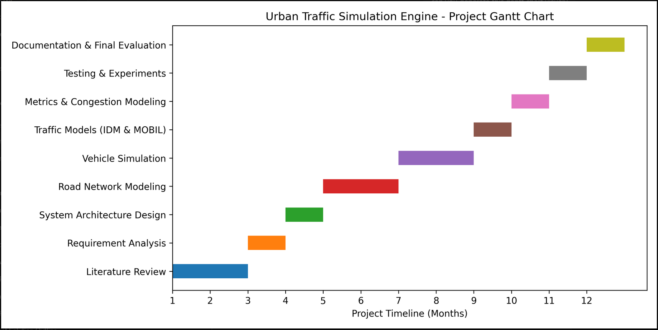
Gantt Chart Representation Of Development Phases
(Diagram 1)

System Architectural and Logical Designs
To make this project implementable we first had to figure out its logical and structural architecture which was done by using Data Flow Diagrams which are shown below:

  - System Architecture & Simulation Pipeline
Architecture Simulation Pipeline
/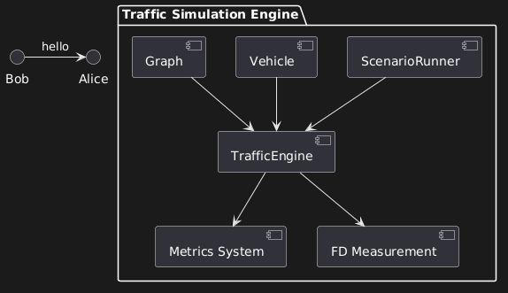 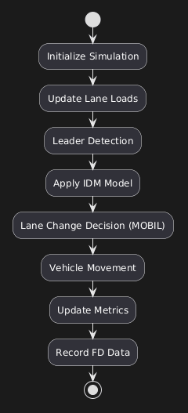

7.2 Data Flow Diagram & Activity Diagram
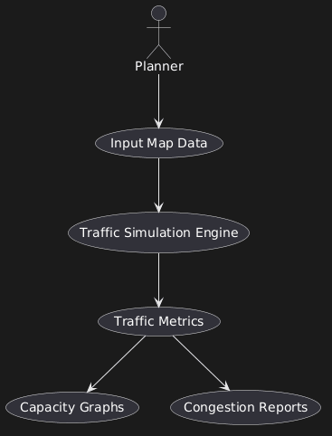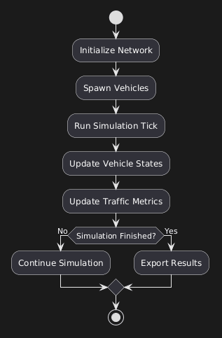
7.3 Object & Class Diagram

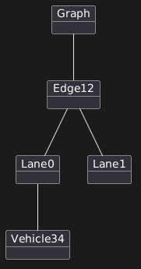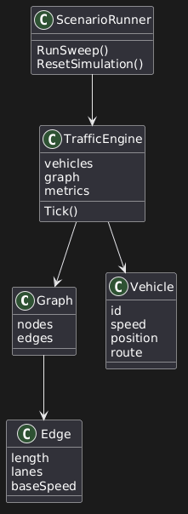

7.4 Vehicle State Machine & Deployment Diagram
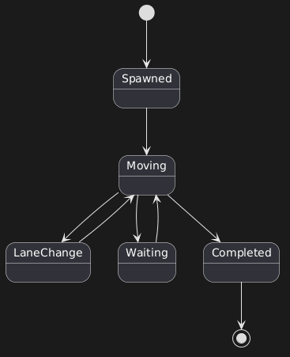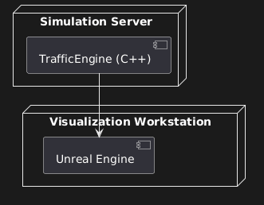

7.5 Use case
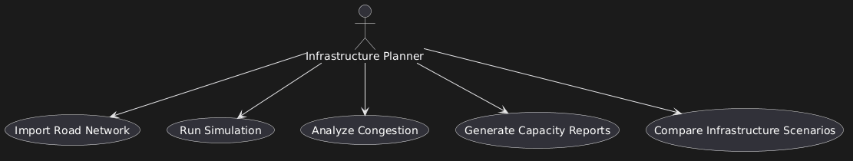
& Sequence Diagram
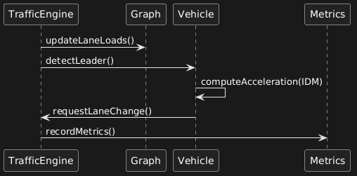

8. References / Bibliography
[1] Treiber, M., & Kesting, A. (2013). Traffic Flow Dynamics: Data, Models and Simulation. Springer.
[2] Kesting, A., Treiber, M., & Helbing, D. (2007). General Lane-Changing Model MOBIL for Car-Following Models. Transportation Research Record.
[3] OpenStreetMap Project. Available at: https://www.openstreetmap.org
[4] Unreal Engine Documentation. Available at: https://docs.unrealengine.com
[5] Hart, P., Nilsson, N., & Raphael, B. (1968). A Formal Basis for the Heuristic Determination of Minimum Cost Paths. IEEE Transactions on Systems Science and Cybernetics.

